**Project Report**

**On**

***“A study on the Paint Industry”***



**Submitted By**

Johora Akther Jui

ID No : 003

Batch : 68

***Date of Submission : 17 February 2025***

**EDGE : BU-CSE Digital Skills Training**

**Computer Fundamentals & Office Applications**

**Instructed By**

Md Mahbub-E-Noor

Assistant Professor

Department of CSE

University of Barishal

*Table of Contents*

Introduction 3

What is the Paint Industry? 3

Historical Background 3

Key Components of Paint 4

1. Pigments (Color & Opacity) 4

2. Binders (Resins) (Adhesion & Durability) 4

3. Solvents (Carrier & Evaporation Control) 4

4. Additives (Performance Enhancers) 5

Types of Paint 5

1. Based on Composition 5

a) Water-Based Paints (Latex Paints) 5

b) Oil-Based Paints (Solvent-Based Paints) 6

2. Based on Function & Purpose 6

a) Architectural Paints (Decorative Paints) 6

b) Industrial Paints (Protective Coatings) 6

c) Automotive Paints 7

d) Specialty Paints 7

3. Based on Finish & Appearance 8

a) Matte Paint 8

b) Satin & Eggshell Paint 8

c) Semi-Gloss & Glossy Paint 8

Market Dynamics 8

Technological Advancements in the Paint Industry 9

1. Smart & Functional Coatings 9

Self-Cleaning Paints 9

Self-Healing Paints 10

Temperature-Regulating Paints 10

2. Eco-Friendly & Sustainable Paints 10

Low-VOC & Zero-VOC Paints 10

Bio-Based & Plant-Based Paints 10

Recyclable & Reusable Paints 10

3. Advanced Nanotechnology in Paints 11

Nano-Coatings for Extreme Protection 11

Antibacterial & Antiviral Paints 11

Air-Purifying Paints 11

4. Digital & Smart Paint Technology 11

Color-Changing Paints (Chromoactive Paints) 11

Conductive & Interactive Paints 11

3D Printable & Sprayable Electronics Paints 12

5. AI & Digital Innovations in Paint Industry 12

AI-Powered Color Matching 12

Automated & Robotic Painting Systems 12

3D Printing of Paint Layers 12

Conclusion 12

# Introduction

## What is the Paint Industry?

The paint industry encompasses the manufacturing and distribution of paints, coatings, and related products used for protective and decorative purposes. The paint industry is a global sector involved in the production and distribution of coatings, paints, and related products. Paints are used for protection, decoration, and functionality across various surfaces. Key segments: Architectural (decorative) paints, Industrial coatings, and Special-purpose coatings.

## **Historical Background**

The use of paints dates back to ancient civilizations, where natural pigments were used to decorate caves and pottery.

Ancient Times: Use of natural pigments and binders like egg whites and plant extracts.

18th Century: Industrial revolution led to the mass production of paints

20th Century: Development of synthetic resins and water-based paints

21st Century: Focus on eco-friendly and high-performance coatings.

# Key Components of Paint

Paint is a complex mixture of various ingredients that work together to provide color, adhesion, protection, and durability. The primary components of paint are:

## 1. Pigments (Color & Opacity)

Pigments are finely ground solid particles that provide color, opacity, and some protective qualities to the paint.

* **Types of Pigments:**
  + **Primary Pigments:** Provide the main color and hiding power (e.g., Titanium Dioxide for white, Iron Oxide for red).
  + **Extender Pigments:** Improve durability and reduce costs (e.g., Calcium Carbonate, Silica, Clay).
  + **Specialty Pigments:** Add unique properties (e.g., Metallic pigments for automotive paint, Fluorescent pigments).
* **Functions:**
  + Provides color and opacity.
  + Enhances UV and chemical resistance.
  + Contributes to durability and hiding power.

## ****2. Binders (Resins)**** (Adhesion & Durability)

Binders are film-forming substances that hold the pigment particles together and help the paint adhere to a surface. Once the paint dries, the binder forms a continuous film that provides durability.

* **Types of Binders:**
  + **Natural Resins:** Linseed oil, Shellac.
  + **Synthetic Resins:** Acrylics, Epoxy, Alkyd, Polyurethane.
* **Functions:**
  + Provides adhesion to the surface.
  + Determines paint durability and resistance to weathering.
  + Affects gloss, flexibility, and hardness.

## ****3. Solvents (Carrier & Evaporation Control)****

Solvents dissolve or disperse the binder and pigment, making the paint fluid enough for application. Once the paint is applied, the solvent evaporates, leaving behind a solid film.

* **Types of Solvents:**
  + **Water-Based Solvents:** Used in latex and acrylic paints (Eco-friendly).
  + **Organic Solvents:** Used in oil-based and industrial paints (e.g., Turpentine, Mineral Spirits, Acetone).
* **Functions:**
  + Adjusts viscosity (thickness) for smooth application.
  + Helps in drying and film formation.
  + Controls the evaporation rate.

## ****4. Additives (Performance Enhancers)****

Additives are specialized chemicals added in small amounts to improve specific paint properties.

* **Types of Additives:**
  + **Thickeners & Rheology Modifiers:** Control flow and leveling (e.g., Cellulose, Polyurethane).
  + **Anti-Settling Agents:** Prevent pigments from settling in the container.
  + **Drying Agents (Driers):** Speed up oxidation and drying (e.g., Cobalt Driers).
  + **UV Stabilizers:** Protect against sun damage and fading.
  + **Anti-Fungal & Anti-Bacterial Agents:** Prevent mold and mildew growth.
* **Functions:**
  + Enhances paint performance and lifespan.
  + Improves application properties and stability.
  + Provides additional protection against environmental factors.

# Types of Paint

Paints are classified based on their composition, application, and purpose. Below are the major types of paint, their characteristics, and common uses.

## Based on Composition

### a) Water-Based Paints (Latex Paints)

Use water as the primary solvent.

Low VOCs (Volatile Organic Compounds), making them eco-friendly.

Fast drying, easy to clean, and widely used for walls and ceilings.

Common Types:

Acrylic Paint: Highly durable, resistant to weathering, used for exterior walls.

Vinyl Acrylic Paint: Cost-effective and ideal for interior walls.

Uses: Home walls, offices, furniture, and ceilings.

### b) Oil-Based Paints (Solvent-Based Paints)

Use organic solvents (e.g., mineral spirits, turpentine).

More durable and glossy compared to water-based paints.

Longer drying time and emits more fumes (higher VOCs).

Common Types:

Alkyd Paint: Used for wood, metals, and high-traffic areas due to its toughness.

Enamel Paint: Hard, glossy finish, resistant to moisture and chemicals.

📌 Uses: Doors, windows, furniture, metal surfaces, and high-traffic areas.

## Based on Function & Purpose

### a) Architectural Paints (Decorative Paints)

Used for residential, commercial, and industrial buildings.

Enhances aesthetics and provides surface protection.

Types:

Interior Paint: Smooth finish, washable, stain-resistant.

Exterior Paint: Weather-resistant, UV-resistant, and mildew-resistant.

Uses: Walls, ceilings, exteriors of buildings.

### b) Industrial Paints (Protective Coatings)

Designed for machinery, pipelines, factories, and infrastructure.

Provides chemical, heat, and corrosion resistance.

Types:

Epoxy Coating: Tough, chemical-resistant, used in factories.

Polyurethane Coating: High durability, scratch resistance.

📌 Uses: Bridges, ships, machinery, refineries, and metal structures.

### c) Automotive Paints

Specifically formulated for vehicles (cars, trucks, motorcycles).

Provides aesthetic appeal and protection from weather, rust, and scratches.

Types:

Basecoat: Provides the main color and is covered with a clear coat.

Clear Coat: Protects the paint, adds gloss, and resists UV damage.

Metallic Paint: Contains metallic flakes for a shiny, reflective look.

Uses: Car bodies, bikes, aircraft, and marine vehicles.

### d) Specialty Paints

Designed for unique purposes such as heat resistance, anti-corrosion, or glow-in-the-dark effects.

Types:

Heat-Resistant Paint: Used for chimneys, boilers, ovens, and engines.

Fire-Resistant Paint: Slows the spread of fire in buildings.

Glow-in-the-Dark Paint: Used for safety signs and artistic designs.

Anti-Microbial Paint: Used in hospitals, kitchens, and humid areas.

Uses: Fire protection, safety signs, industrial plants, and hospitals.

## Based on Finish & Appearance

### Matte Paint

Non-reflective, smooth finish, hides surface imperfections.

Uses: Ceilings, interior walls, and low-traffic areas.

### Satin & Eggshell Paint

Slight sheen, easy to clean, better durability than matte.

Uses: Living rooms, bedrooms, and offices.

### Semi-Gloss & Glossy Paint

High shine, moisture-resistant, easy to clean.

Uses: Kitchens, bathrooms, doors, windows, furniture.

# Market Dynamics

Global demand driven by construction, automotive, and industrial sectors. Shift towards eco-friendly and sustainable paints due to regulatory pressures and consumer preferences. The paints and coatings market size has grown strongly in recent years. It will grow from $247.72 billion in 2023 to $267.22 billion in 2024 at a compound annual growth rate (CAGR) of 7.9%. The growth observed in the historic period can be credited to the boom in construction and real estate, trends in the automotive industry, growth in industrial manufacturing, adherence to environmental regulations, and fluctuations in raw material prices. The paints and coatings market size is expected to see strong growth in the next few years. It will grow to $355.12 billion in 2028 at a compound annual growth rate (CAGR) of 7.4%. The anticipated expansion during the forecast period is ascribed to the adoption of green and sustainable practices, swift urbanization, economic development in emerging markets, emphasis on infrastructure renewal, and adherence to stringent safety standards. Key trends expected in the forecast period encompass the integration of digitalization in manufacturing, the utilization of smart coatings and nanotechnology, continuous technological advancements, the emergence of bio-based and sustainable coatings, and a heightened focus on high-performance coatings.

The anticipated growth of the paint and coatings market is driven by the increasing consumption in end-user industries. There is a notable surge in the usage of paints and coatings across various sectors such as automotive, construction, and manufacturing. These coatings play a crucial role in protecting surfaces, enhancing aesthetics, and providing corrosion resistance in the construction industry. For example, in June 2023, data from the U.S. Census Bureau and the U.S. Department of Housing and Urban Development revealed that privately owned home starts were growing at a seasonally adjusted annual rate of 1,631,000, marking a substantial increase over the previous predictions and rates in April 2023 and May 2022. This trend is expected to contribute to the overall growth of the paint and coatings market.

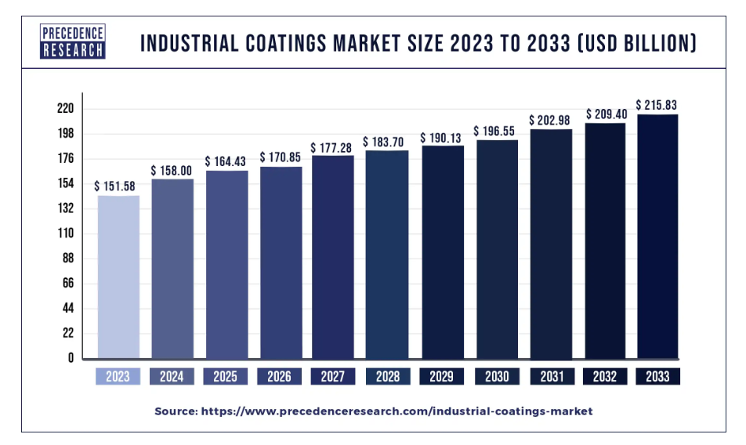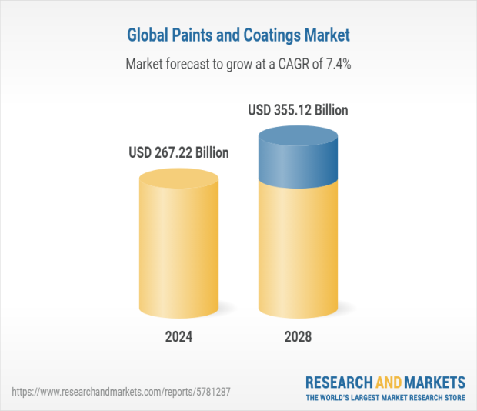

# Technological Advancements in the Paint Industry

The paint industry has seen significant technological advancements to improve performance, durability, sustainability, and efficiency. Here are some of the latest innovations:

## Smart & Functional Coatings

### Self-Cleaning Paints

Uses nanotechnology to create a surface that repels dirt, dust, and water.

Example: Lotus Effect Paints (inspired by lotus leaves) for buildings and cars.

### Self-Healing Paints

Uses microcapsules filled with resins that repair small scratches when exposed to heat or UV light.

Common in automotive and aerospace industries.

## Temperature-Regulating Paints

Reflects heat in hot weather and retains warmth in cold conditions.

Used for energy-efficient buildings and automotive applications.

## Eco-Friendly & Sustainable Paints

### Low-VOC & Zero-VOC Paints

Traditional paints release harmful Volatile Organic Compounds (VOCs), contributing to air pollution.

Modern paints use water-based formulas with minimal or no VOCs, reducing health risks.

### Bio-Based & Plant-Based Paints

Made from natural ingredients like soybean oil, algae, and plant resins.

Example: Milk Paint, a non-toxic, biodegradable paint used in eco-friendly homes.

### Recyclable & Reusable Paints

New technology enables recycling of leftover paints to reduce waste.

# Advanced Nanotechnology in Paints

### Nano-Coatings for Extreme Protection

Uses nano-sized particles for superior durability, UV resistance, and waterproofing.

Example: Ceramic Coatings in car paints protect against scratches and oxidation.

### Antibacterial & Antiviral Paints

Infused with silver nanoparticles or copper ions to kill germs and bacteria.

Used in hospitals, schools, and food industries.

### Air-Purifying Paints

Contains photocatalytic titanium dioxide (TiO₂) to break down pollutants and purify indoor air.

Helps remove formaldehyde, carbon monoxide, and other toxins.

## Digital & Smart Paint Technology

Color-Changing Paints (Chromoactive Paints)

Uses thermochromic (heat-sensitive) or photochromic (UV-sensitive) pigments.

Example: Chameleon Car Paints that change color with temperature or light exposure.

### Conductive & Interactive Paints

Paints infused with graphene or conductive materials that allow surfaces to conduct electricity.

Used in smart homes to create interactive walls or touch-sensitive surfaces.

### 3D Printable & Sprayable Electronics Paints

Paints embedded with printed electronic circuits for advanced applications in wearable tech and home automation.

## AI & Digital Innovations in Paint Industry

### AI-Powered Color Matching

Artificial Intelligence (AI) helps customers find the perfect paint color through smartphone apps and online tools.

Example: Dulux Visualizer App, which shows how a color will look on walls before painting.

### Automated & Robotic Painting Systems

AI-driven robots apply paint in industries like automotive, construction, and aerospace.

Increases precision, speed, and efficiency while reducing human error.

### 3D Printing of Paint Layers

Allows for customized textures and designs by layering paint with precision.

Used in high-end furniture and artistic applications.

# Conclusion

The paint industry plays a crucial role in various sectors, including construction, automotive, industrial, and decorative applications. Over the years, it has evolved from using natural pigments and oils to high-performance, eco-friendly, and technologically advanced coatings. Sustainability in the paint industry is shaping the future of coatings, focusing on reducing pollution, conserving resources, and enhancing human health. With increasing eco-conscious consumer demand and regulatory pressures, the industry is moving towards greener, safer, and smarter solutions. The paint industry is a dynamic and essential sector that enhances aesthetics, protects surfaces, and improves sustainability. While facing challenges related to environmental impact and raw material supply, the industry's future is driven by innovation, green chemistry, and smart coatings. With continuous advancements, it is expected to become more sustainable, efficient, and technologically advanced, paving the way for a greener and smarter future.